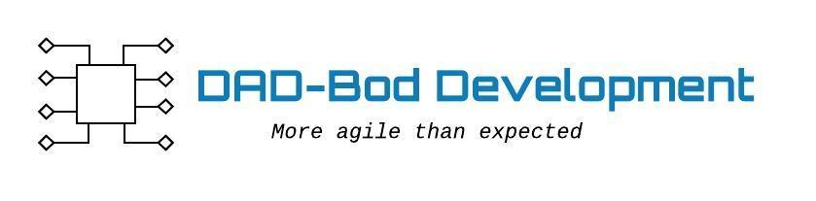

**Agile Data Modeling - Entities, E-R Diagram**

